A Closed-Loop System for Treatment and Prevention of Bruxism

By: Aditya Krishna, Elijah Mccoy Reeb, Emily Rodgers, Frenda Lin, Poojitha Arangam

**Table of Contents**

**Problem Statement 2**

**Solution 3**

Possible Future Enhancements/ Extensions 3

**Target Users 5**

Bruxism Sufferers 5

Patients Diagnosed with Bruxism 5

Those Seeking Preventative Measures 5

Dental Professionals 5

Research Institutions and Clinics 5

**Potential Impact 6**

Improved Dental Health 6

Reduced Pain, Enhanced Comfort, and Quality of Life 6

Behavioral Modification 6

Stress Reduction 6

**Questions, Concerns, and Considerations 7**

Accuracy and Reliability 7

User Comfort and Compliance 7

Safety and Risk Mitigation 7

Privacy and Data Security 7

Clinical Validation and Regulatory Compliance 7

Customization and Personalization 7

Integration with Existing Treatments 7

Long-Term Efficacy and Follow-Up 8

Cost and Accessibility 8

Ethical Considerations 8

# 

# 

# 

# Problem Statement

Bruxism, or teeth grinding, affects millions of people worldwide, often leading to dental problems, discomfort, and reduced quality of life. Despite its prevalence, current approaches to bruxism management are limited by their reliance on subjective symptoms and reactive interventions. There is a critical need for an intelligent solution that can accurately detect bruxism episodes in real-time, provide personalized insights into underlying risk factors, and empower users to take proactive steps to manage their condition effectively. Our proposed device addresses this need by leveraging real-time analytics as well as machine learning technology to revolutionize bruxism management, offering users a smarter, more proactive approach to optimizing their oral health.

# 

# Solution

The device will utilize EMG sensors strategically placed on the jawline to accurately detect muscle activity associated with teeth grinding. When bruxism is detected, the device immediately responds with gentle vibrations, acting as a subtle reminder for the wearer to relax their jaw muscles. Through consistent use, the device helps users become more mindful of their bruxism habits, ultimately training them to reduce or eliminate teeth grinding altogether. The device is combined with an app that gives users advanced data insights into their bruxism habits so they can see trends in their bruxism behaviors over time.

## Possible Future Enhancements/ Extensions

* Pattern Recognition for Enhanced Detection: The device will utilize machine learning algorithms, such as convolutional neural networks (CNNs) and recurrent neural networks (RNNs), to analyze electromyography (EMG) signals and accurately detect bruxism episodes in real-time. By training the model on a diverse dataset of EMG recordings, the system will learn to recognize subtle muscle activity patterns associated with teeth grinding with high accuracy and sensitivity.
* Predictive Analytics for Risk Assessment: In addition to detecting bruxism episodes, the device will employ predictive analytics techniques, including time series analysis and feature engineering, to assess users' risk factors and identify potential triggers contributing to teeth grinding. By analyzing longitudinal data encompassing sleep patterns, stress levels, and environmental variables, the system will provide personalized insights into the underlying causes of bruxism and offer proactive mitigation strategies tailored to individual users' needs.

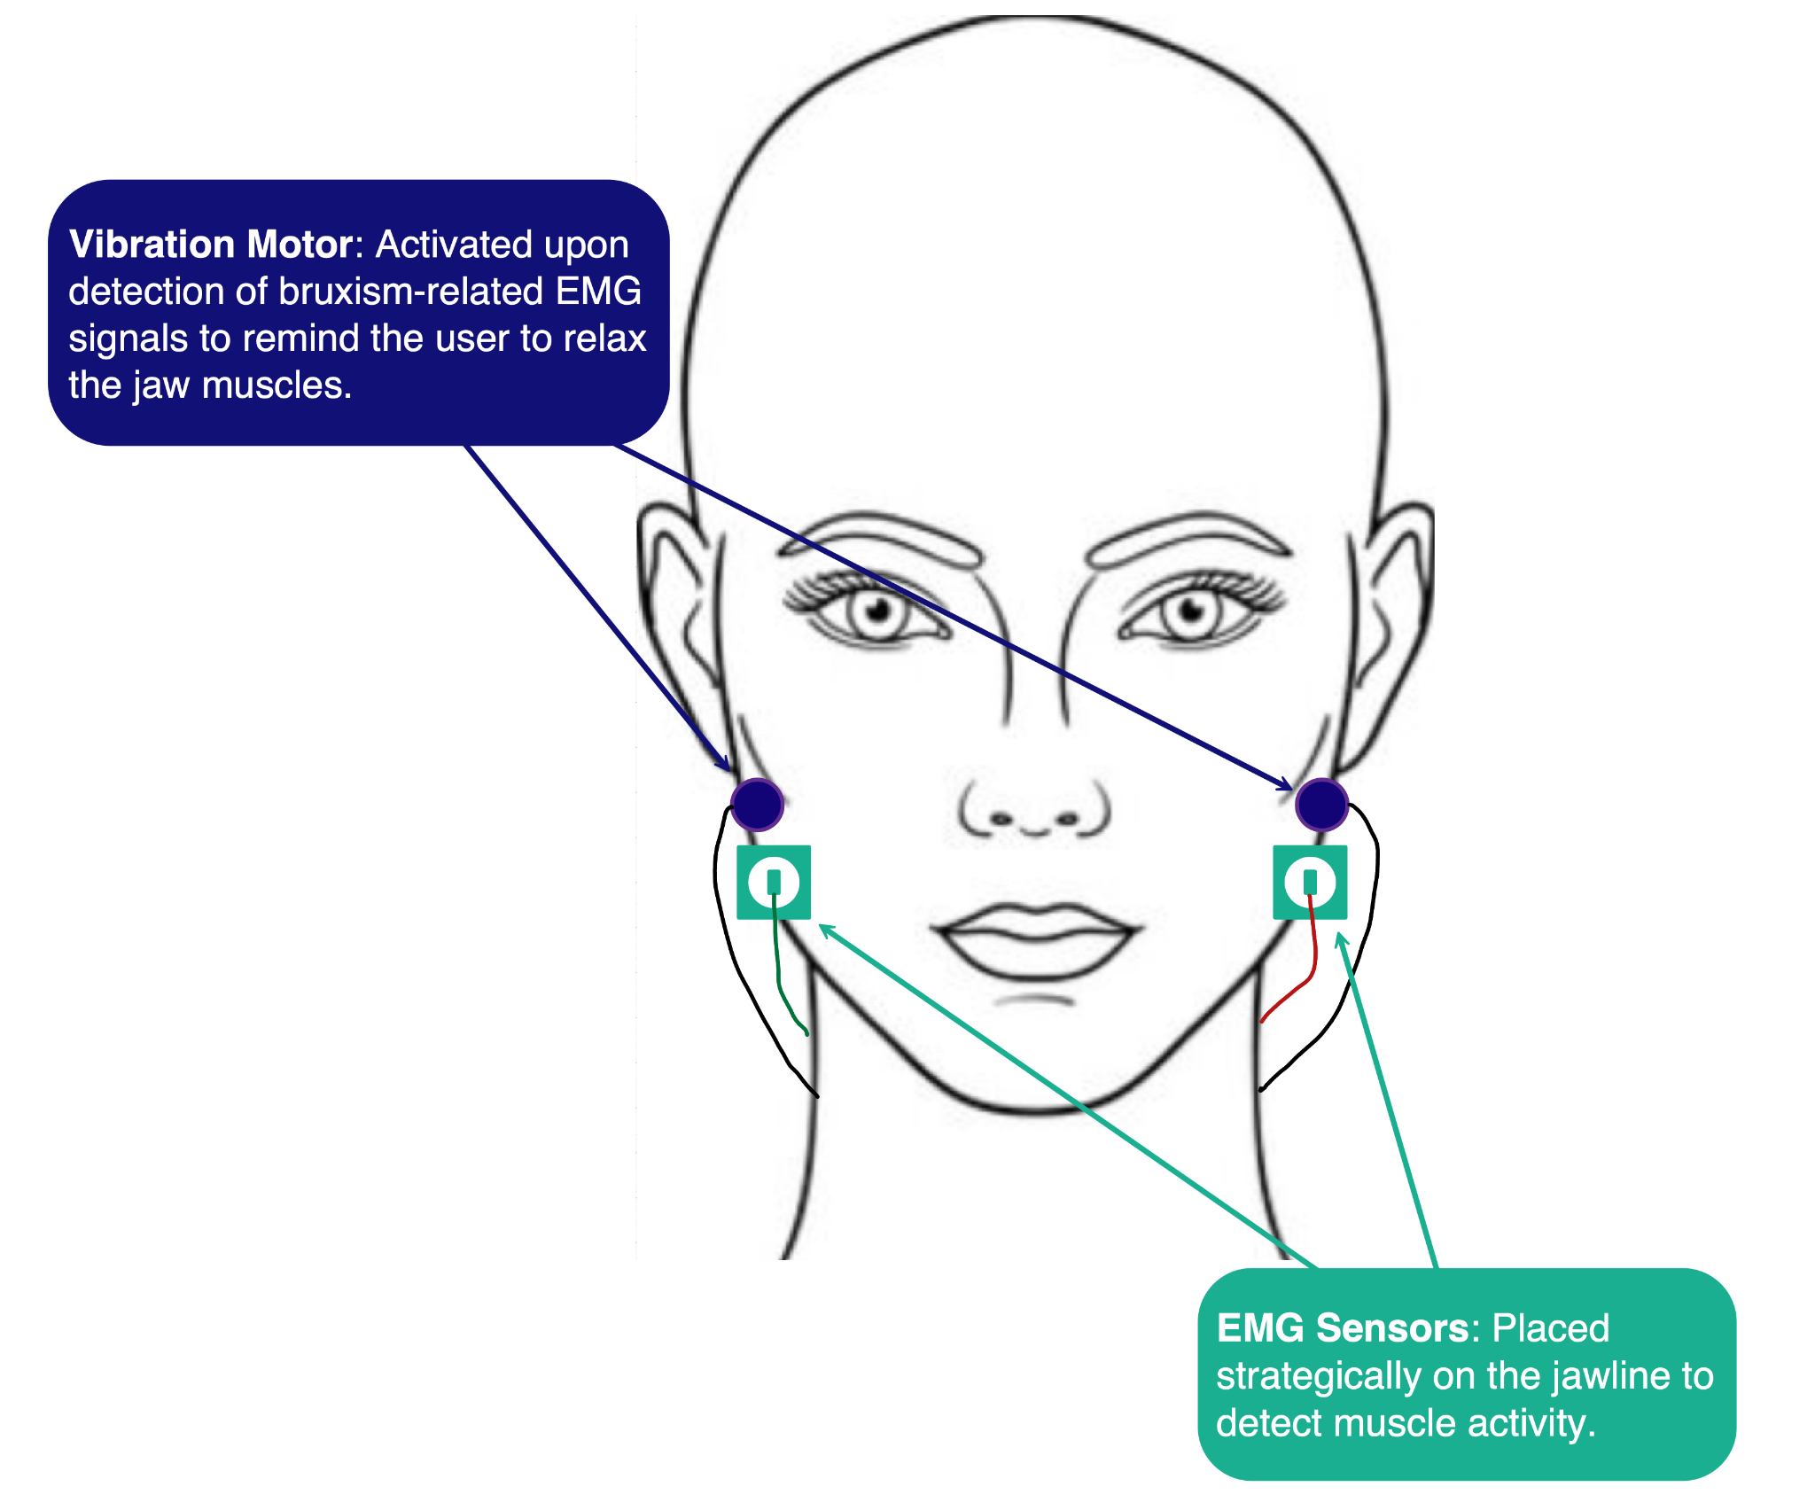

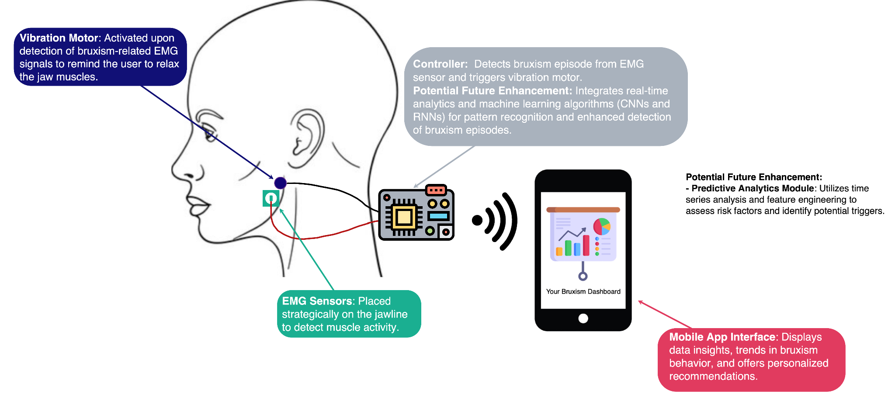

# Target Users

### Bruxism Sufferers

Individuals who experience symptoms of bruxism, such as teeth grinding or clenching, and seek relief from associated discomfort and dental problems.

### Patients Diagnosed with Bruxism

Individuals who have been clinically diagnosed with bruxism by dental professionals and require a proactive management strategy to mitigate the condition's impact on their oral health.

### Those Seeking Preventative Measures

Individuals who are aware of their susceptibility to bruxism due to factors such as stress, sleep disturbances, or temporomandibular joint (TMJ) disorders and wish to adopt preventative measures to reduce the risk of dental damage.

### Dental Professionals

Dentists, orthodontists, and dental hygienists who are interested in incorporating innovative technologies into their practice to enhance patient care and outcomes.

### Research Institutions and Clinics

Academic researchers and healthcare institutions engaged in studying bruxism, its underlying mechanisms, and the efficacy of interventions. The device could serve as a valuable tool for conducting clinical studies and collecting data to advance scientific understanding in the field of bruxism management.

# 

# Potential Impact

### Improved Dental Health

Potential to prevent dental damage, such as enamel erosion, tooth wear, and fractures. This can lead to improved oral health outcomes and reduced need for costly dental treatments associated with bruxism-related complications.

### Reduced Pain, Enhanced Comfort, and Quality of Life

Those affected by bruxism often experience discomfort, jaw pain, headaches, and disrupted sleep patterns. The mitigation and prevention of bruxism could help relieve these painful and disruptive symptoms.

### Behavioral Modification

Through personalized insights and feedback, the device will empower users to become more aware of their bruxism patterns and adopt proactive measures to mitigate the condition's impact. Over time, users may develop healthier habits and behaviors that reduce the frequency and intensity of teeth grinding episodes, leading to long-term behavioral modification and symptom reduction.

### Stress Reduction

Bruxism is often associated with stress and anxiety, which can exacerbate teeth grinding. By incorporating predictive analytics to identify stress-related triggers and offering personalized recommendations for stress management techniques, the device may contribute to stress reduction and improved mental well-being for users.

# 

# Questions, Concerns, and Considerations

### Accuracy and Reliability

* How accurate and reliable is the detection of bruxism episodes using EMG signals and machine learning algorithms?
* What measures will be implemented to validate the system's performance and ensure consistent results?

### User Comfort and Compliance

* How comfortable and user-friendly is the wearable device?
* What strategies will be employed to encourage user compliance and long-term usage of the proposed device?
* When will users wear the device?

### Safety and Risk Mitigation

* Are there any potential safety concerns associated with the use of the proposed device, such as allergic reactions to materials or unintended side effects of the gentle vibrations?
* How will these risks be identified, assessed, and mitigated?

### Privacy and Data Security

* How will user data collected by the proposed device be stored, processed, and protected to ensure privacy and compliance with data protection regulations?
* What measures will be implemented to prevent unauthorized access or misuse of sensitive information?

### Clinical Validation and Regulatory Compliance

* What steps will be taken to validate the effectiveness and safety of the proposed device through clinical trials and studies?
* How will the device comply with regulatory requirements and obtain necessary approvals for marketing and distribution?

### Customization and Personalization

* How will the proposed device accommodate individual differences in bruxism patterns, severity, and response to intervention?
* What mechanisms will be in place to personalize feedback and recommendations for each user based on their unique needs and preferences?

### Integration with Existing Treatments

* How will the proposed device complement or integrate with existing bruxism treatment modalities, such as dental splints or behavioral therapy?
* What collaboration opportunities exist with dental professionals to ensure comprehensive and coordinated care for users?

### Long-Term Efficacy and Follow-Up

* What strategies will be implemented to assess the long-term efficacy of the proposed device in managing bruxism and preventing dental complications?
* How will user progress be monitored, and what mechanisms will be in place for follow-up and support?

### Cost and Accessibility

* What will be the cost of the proposed device, and how will it compare to existing bruxism management options?
* How can the device be made accessible to a diverse range of users, including those with limited financial resources or healthcare access?

### Ethical Considerations

* Are there any ethical considerations, such as equity, fairness, or potential biases, that need to be addressed in the development and deployment of the proposed device?
* How will ethical principles guide decision-making throughout the project lifecycle?